**Day 1 Lab Assignmentshttps://drive.google.com/drive/folders/1weB5KfGOpN2o7XjDYMdmwTJZuicuLjHo?usp=sharing**

2. You can use your old home page layout (In JS labs) instead of the following image if you like)
3. Pay more attention for layout, not of the content.
4. Make you page fully responsive (use viewport meta tag).
5. DON’T use tables in you layout, use divs & spans (or new HTML 5 structural elements), with CSS instead.
6. **Use flexbox instead of floating**.
7. Try flex wrap properties, to make sure that the columns will appear below each other in the small size.
8. Make you images, Video responsive.
9. Don’t use media queries, use the default action of flex box (The left bar its size will only decreased on its place).

1. Use Media query and CSS breakpoints your website layout on normal laptops and PCs, tablets and smart phones (as shown in the prev. image):
   1. You can use your old home page layout (In JS labs) instead of the following image if you like)
   2. Design the tablet view, and hide the left column on tablet size and make the middle part fill the width. (Use media queries on CSS file and breakpoints).
   3. When you hide the left column, make it appear as row (width 100%) above or below (as shown in above image for tablet view).
   4. Design the mobile view hide banner image and left column (Use media queries on CSS file and breakpoints).

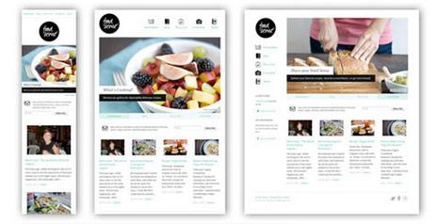

1. Use grid layout with your CV page design, and make sure that it’s completely responsive (use viewport meta tag):
   1. Change the middle content in the given image to be full-page width.
   2. Use 16 columns layout.
   3. Set box-sizing property.
   4. Use Viewport units with the font size for text in the header (Name), and max-width with the image.
   5. Use float property
   6. Use **flex** instead of float (**Bonus**).
   7. Change the header image in tablet and mobile view (Use picture tag).

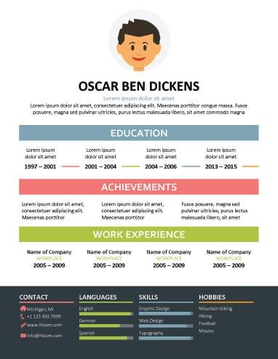

**Bonus Assignments:**

1. Redo first assignment using Grid-layout.
2. Use column-based design to design the following template:

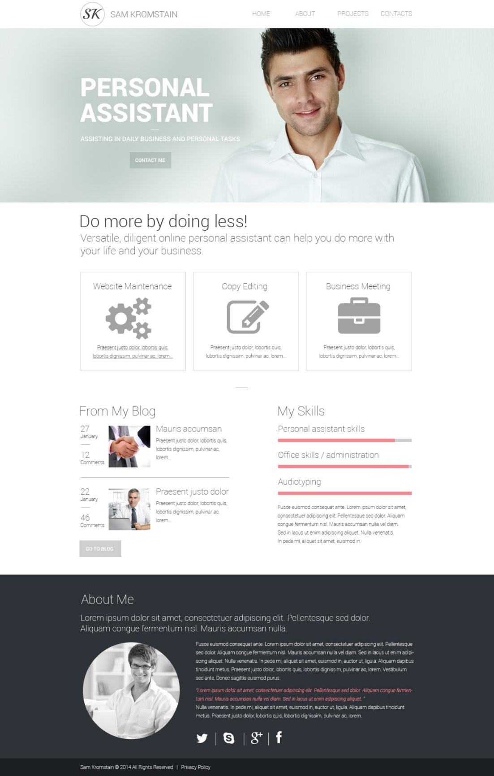

1. Redo the same design using “Mostly fluid” and “Off-canvas” RWD pattern, and try different RWD patterns generally.
2. What’re CSS frameworks? Search for different frameworks and list their features, and differences between them?
3. What’re CSS pre-processor? Search for different frameworks and list their features, and differences between them.
4. What’s BEM? Explain using demo.
5. What’s material design? Explain using demo.

**<Thank>YOU </Thank>**